BSc Initial Report
Submitted for the
BSc Honours in Computer Science
October 2009
Virtual Tourism Website
By
Paul Ness
Contents
1. Introduction 3
1.1. The Original Brief for the Project: 3
2. Background research 4
3. Technical Research 6
ASP.net overview: 6
PHP overview: 6
4. Specification 7
4.1. Requirements Analysis 7
Functional Requirements 7
Non-Functional Requirements 8
4.2. Risk Analysis 9
4.3. Ethical Considerations 10
4.3.1. Legal Issues (IPR) 10
5. Task List 11
Initial Report (24 days) 11
Interim Report (60 days) 11
Final Report (70 days) 11
Web site development (27 WOrking weeks - concurrent tasks) 12
Design stage (20 days): 12
Implementation stage (90 Days): 12
Verification Stage (25 Days): 12
6. Gantt Chart 13
7. Bilbliography 13
8. References 14

Word Count 2153. (excluding contents & bibliography)

virtual tourism
for the east riding of yorkshire

Introduction
The aim of this project is to provide a data driven website that provides users with an interactive holiday booking process for hotels located near places of interest in the East Riding. The site will not only provide the simple action of booking the hotel but provide an interactive web photo tour of the hotel grounds, rooms and lobby.
Example layout for the photo tour:
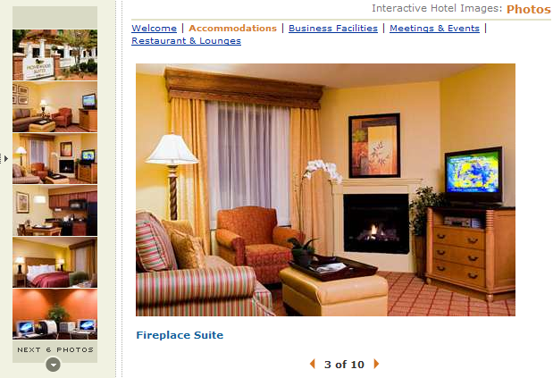
A range of activities from day trips, walking, golf and adventure/sports activities will be available to the guests during their stay and information is to be provided about these activities through the site. We will also display icons displaying the amenities provided by the hotel.
Example icons for hotel amenities:
Our target visitors will be families looking for short breaks we will arrange outings to places like Robin Hood Bay with fossil hunts and prizes for the kids, however we will also cater for large groups arranging alternative activities such as Go Ape and an organised day out in Bridlington for them.

The Original Brief for the Project:
”East Yorkshire is a very picturesque place with many interesting places and activities to do, could you produce a virtual east riding as an aid to tourism. Potential tourists could thus sample a holiday and experience the look and feel of the area before they spent any money. In this way it would act as a multimedia taster for the real thing. Subsequently the system should be an e-business which would let the user book the holiday that they wished to purchase. The project will thus include database technology hooked to the web along with appropriate visuals and interactive facilities.”

Background research
There is an existing web presence albeit non-profit that aims to provide information for tourists visiting the East Riding allowing users to display upcoming events, view attractions, request brochures and provide a booking system to third party hotels. We aim to differentiate our site by providing an inclusive holiday with set organised activities for our guests who will be staying at our hotel.
(Real Yorkshire, Places to Stay)
Consumer research shows that short holiday breaks of 1-3 nights account for almost two-thirds of all holiday/leisure breaks in the UK unusually demand for domestic activity holidays is also predicted to increase this will obviously benefit our venture.
Domestic activity holidays taken 2003-13:
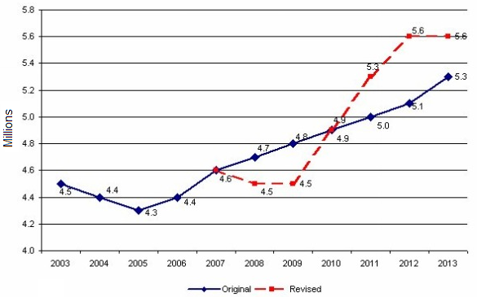
(Mintel, March 2009, Market Re-forecasts Travel UK)
Over 40.1 million holidays were taken in the UK in 2008 and there is a 72% occupancy rate in hotels. Through user feedback from previous guests and providing activity holidays for corporate and elderly groups we can increase occupancy rates during winter months.
Strengths and weaknesses in UK Hotel Market:
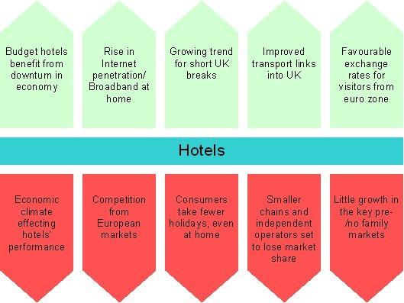
(Mintel, November 2008, Hotels - UK)
There are many activities we can offer visitors of our hotel we could plan an organised walk in Robin Hood Bay with a fossil and shell hunt for the kids, a venture deal with Go Ape in Dalby forest offering a fun day out for large groups also the possibility of a arranging a Yachting trip with Welton Sailing Club.
See Below (Go Ape, left), (Welton Water, centre) & (Robin Hood Bay, right):
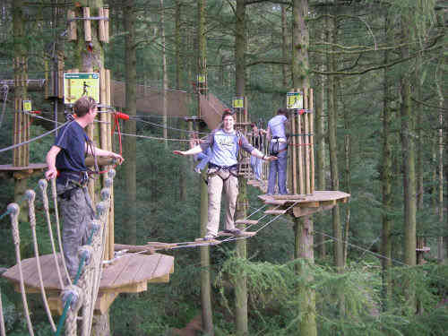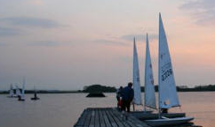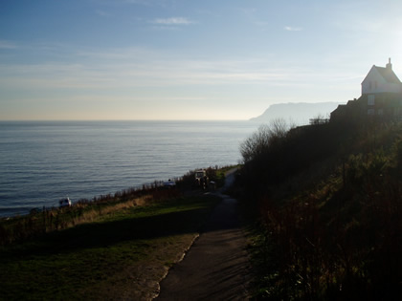
Holiday market in the UK split by sector:
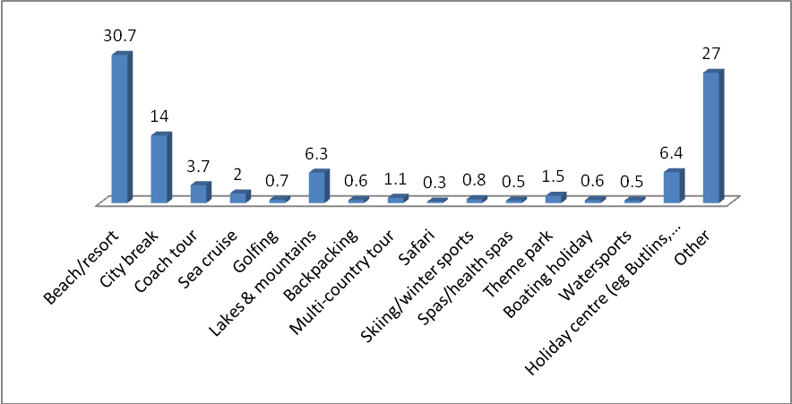
(Mintel, Q1 (Oct-Sep) 2005-09, GB TGI BMRB)
We will plan events according to demand as some visitors prefer quiet countryside walks, some prefer market stroll in Beverley and others prefer enjoying the amusements in Bridlington, catering for these very different needs is a large task.

Technical Research
In order to decide what framework we will be using for our website we are going to explore two technologies: PHP coupled with MySQL or Microsoft ASP.net using C# and SQL.
Although we can accomplish the task of building our data driven website in either of the two languages so it was just deciding which one was most suitable for the task.

ASP.net overview:
It can be programmed with either C# or VB and is coupled with object orientated features and flexibility. The simple ability to use Visual Studio IDE which includes IntelliSense is a bonus however on the other hand it is a resource hog for the web server since all functions are executed on the servers side. ASP.net also has considerable licensing costs; this has no effect on this academic project however it is a point to consider.

PHP overview:
Strength lies in the LAMP architecture PHP is open source and inexpensive for commercial projects, it can be used with a large number of relational database management systems. PHP is lightweight and compatible with many different OS it is now over 18 million web servers have PHP installed. PHP 5 adds Object Orientated Programming and some of the high level features included in ASP.net.
(Kevin Jordon, Web Languages: PHP vs. ASP.NET)
We will decide to use ASP.net for this project due to its IDE being available in the computer labs, the rapid OOP development that we can use to produce the project efficiently and the fact we are not subject to commercial licensing fees.
Prototype database design:
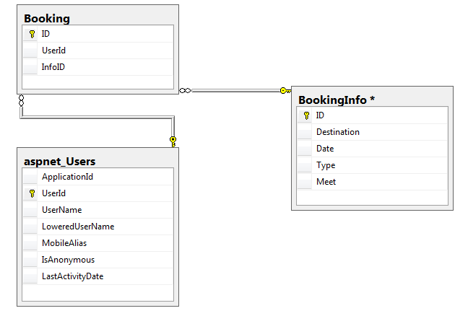

Specification

4.1. Requirements Analysis
After meeting with the client we have decided on a few additional features such as the user being able to view the activities and events during their visit and book the activities they wish to attend this will allow hotel staff to allocate places and ensure activities are not overbooked thus guests will not disappointed.
Importantly for the elderly and infirm the website should also allow entry of dietary, accommodation, disability access and other special needs via a field in the booking process.

Functional Requirements
- Handle multiple users and provide sessions per user with log-in/log-out controls
- Provide a virtual photo tour of the hotel grounds, lobby and rooms
- Provide group bookings include checkboxes for special events and occasions
- Provide information (time, meeting place, travel & destination) about activities
- User information and bookings must be accessible by the user logged-in only
- User must be able to cancel bookings
- A forgotten password page must be developed
- Hotel will have 35 rooms and the number of bookings must not exceed this number
- Bookings must not overlap so validation must prevent this
- Activities may have a maximum number of participants this cannot be exceeded
- Each activity will contain a photo album which can be cycled through
- Guests cannot book the same activity twice

Non-Functional Requirements
- Users will be able to leave feedback on the overall stay at the hotel
- Users can leave feedback about activities attended during their stay
- The most recent 3 feedbacks may be displayed
- Users will be able to upload photos of the activities attended
- Users will be able to specify ‘special needs’ or requests during their booking
- Provide transport information

Risk Analysis
Risk | Significance | Likelihood | Severity | Evaluation | Strategies
Scope creep | HL | High | Low | Uncontrolled changes to the project scope for example the projects original scope did not account for a feature the requirements relied on. | To stop the project overrunning its schedule, specification will be produced each deadline with schedule updates
Client changes specification | ML | Medium | Low | Some aspects of the project the client may not approve of thereby needing changes, adding risk and time to the project | Weekly progress meetings with client to ensure the project is ‘on the right track’
Outside influence | HM | High | Medium | Downtime of working days allocated to the project | Ensure internal deadlines defined in the schedule are met & make the project priority
Learning new technology | MH | Medium | High | Problems with SQL and ASP | Undertaking learning ASP.net now, through online and books and get advice from personal supervisor
Hard disk failure | LH | Low | High | Project may become corrupted | Data is synchronized between three different sources including university G:/ drive

Ethical Considerations
Allowing guests to upload photos of outings and give feedback could result in the following ethical issues:
- Abuse of service - uploading inappropriate or pornographic photos
- Abusive feedback - comments racist, hateful or otherwise offensive
- User uploading photos that contain harmful script in order to bring down the server or retrieve information from the database
The solution for the inappropriate content for is to have a permanent volunteer moderator as exists in many forums, warnings and possibly account closures to be given to users not complying with our ethical policies.
Some image formats contain a security flaws in the decoding process which allows harmful code to be executed that affects data outside the image for example .png files had been hacked in the past to alter the providing websites appearance by accessing its CSS information.
(CNET, 2004, Image Flaw Pierces PC Security)
The solution for the harmful script is to use ASP.net validation controls to decode the file as an image of using the decoder that matches its file type if this passes it will be checked for additional script and if it fails at any checkpoint the image upload will be rejected.

Legal Issues (IPR)
To ensure that our website is keeping in line with the current copyright laws all the images have been personally photographed by the web administrator including the banner.
See below:
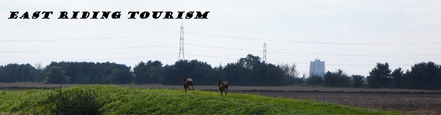
All efforts have been made to not photograph any faces of the public in any of the pictures, however the user uploaded content is beyond control of the administrator to prevent legal issues, daily monitoring of website feedback and images will be in effect.
The Data Protection Act 1998 dictates that we must not hold user data for purposes outside the website purposes and we can only hold data from inactive accounts for a limited period of time before information is deleted from the database.
Computer Misuse Act 1990 enforces us to prevent unauthorized access to data held by use of the C# cryptography libraries to ensure data transfers are kept secret.

Task List
The reports are completed alongside the project which is organised using iterative waterfall model; all tasks within each stage of this model are run in the sequence represented in the Gantt chart.
Tasks will be allocated 2-5 hours per weekday spent in the FE-52B computer labs. This equates to about 10-25 hours per week until 03 May 2010. Some weeks may not reach this expectation however others will exceed it.

Initial Report (24 days)
This consists of 2000 words will be completed alongside the web site design stage.
- Meet with supervisor and record minutes from meeting
- Decide layout for report
- Introduction section
- Background review
- Specification
- Time plan charts and bibliography

Interim Report (60 days)
This consists of around 3000 words and will be completed alongside the web site implementation stage.
- Project introduction (7 days)
- Background review (8 days)
- Bibliography & scope (7 days)
- Progress review (5 days)

Final Report (70 days)
15,000 words and between 40-50 pages this is the final deliverable for the project and consists of the following.
- Project abstract and introduction
- Background research – into the tourism industry, similar web sites, IPR issues, ASP.net, SQL Server & East Riding of Yorkshire.
- Project lifecycle – any differences to the specification and deviation from the schedule
- Progress review – Summary of major milestones, time management, lessons learnt, technical issues resolved and outstanding issues.
- Bibliography
- Technical achievements
- Client and independent feedback
- Conclusion and evaluation

Web site development (27 WOrking weeks - concurrent tasks)

Design stage (20 days):
- Design UI layout for website (2 days)
- Construct a sitemap and organize navigation (3 days)
- Outline what data structures the website will need (5 days)
- Research the tourist sites and visit them if needed to obtain photos and information (10 days)

Implementation stage (90 Days):
- Produce the website user interface
- Create the SQL database
- Code the functionality behind the controls
- Connect the SQL database to the controls
- Provide user sessions and log-in access
- Additional features

Verification Stage (25 Days):
- Perform validation on the forms (8 days)
- Add security to the database and user sessions (5 days)
- Test the website thoroughly (8 days)
- Manipulate the database to provide data reports and administrative access (12 days)

Gantt Chart
All tasks stop throughout Christmas holidays (21/Dec/2009 – 17/Jan/2010) and just one task starts near the end of the Christmas holidays and runs during exam period. The schedule is flexible to change and each task will likely be completed in advance of this schedule.
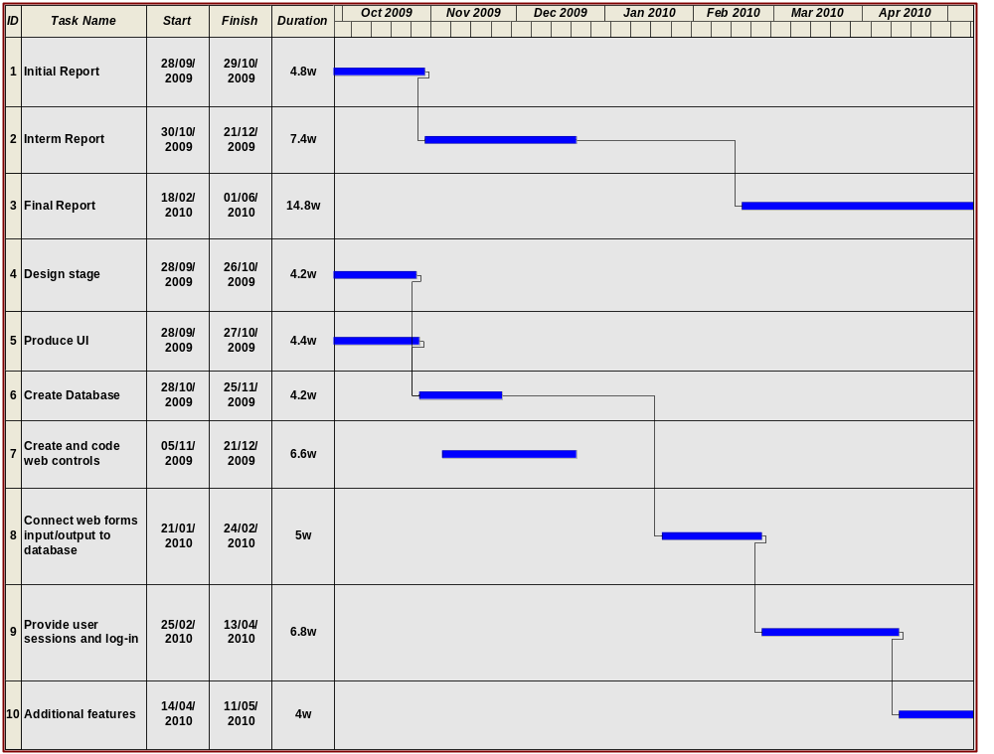

Bilbliography
Onion, F, 2003
Essential ASP.net with Examples in C#
USA: Pearson Education
Price, J, 2003
C# Complete
USA: Sybex
Jones, A, 2004
C# Programmers Cookbook
USA: Microsoft Press
Walther, S, 2002
ASP.net Unleashed
USA: Sams Publishing
Laudon, K, 2002
E-Commerce: business, technology, society
UK: Addison Wesley
Laudon, K, 2002
Management Information Systems
UK: Addison Wesley

References
Mintel, March 2009. Market Re-Forecasts – Travel UK [online]
Avaliable: http://academic.mintel.com/sinatra/oxygen_academic/subject/view=reports_category&levels=126379/cat_items/cat=19&type=RCItem&list=cat_items/display/id=447359
(Accessed 15/October/2009)
Mintel, November 2008, Hotels – UK [online]
Avaliable: http://academic.mintel.com/sinatra/oxygen_academic/my_reports/display/id=280410&anchor=atom/display/id=429270?select_section=280410
(Accessed 25/October/2009)
Real Yorkshire, Places to Stay [online]
Avaliable: http://www.realyorkshire.co.uk/accommodation/places-to-stay.aspx
(Accessed 25/October/2009)
Go Ape, Ongoing. Dalby Forest UK [online]
Avaliable: http://www.goape.co.uk/days-out-in/north-yorkshire/dalby/the-course
(Accessed 15/October/2009)
Cnet, August 2004, Image flaw pierces PC security [online]
Avaliable: http://news.cnet.com/Image-flaw-pierces-PC-security/2100-1002_3-5298999.html
(Accessed 15/October/2009)
Kevin Jordon, Date Unknown, Web Languages: PHP vs. ASP.NET [online]
Avaliable: http://resources.bravenet.com/articles/web_programming/asp/web_languages_php_vs_aspnet
(Accessed 15/October/2009)
Welton Sailing Club, 2009, About [online]
Avaliable: http://www.weltonsc.org/index.php/about
(Accessed 25/October/2009)

